Practical: 5 | Implementation of a knapsack problem using dynamic programming.
25/08/2026
Aim: To Implement the knapsack problem using dynamic programming.

Algorithm :
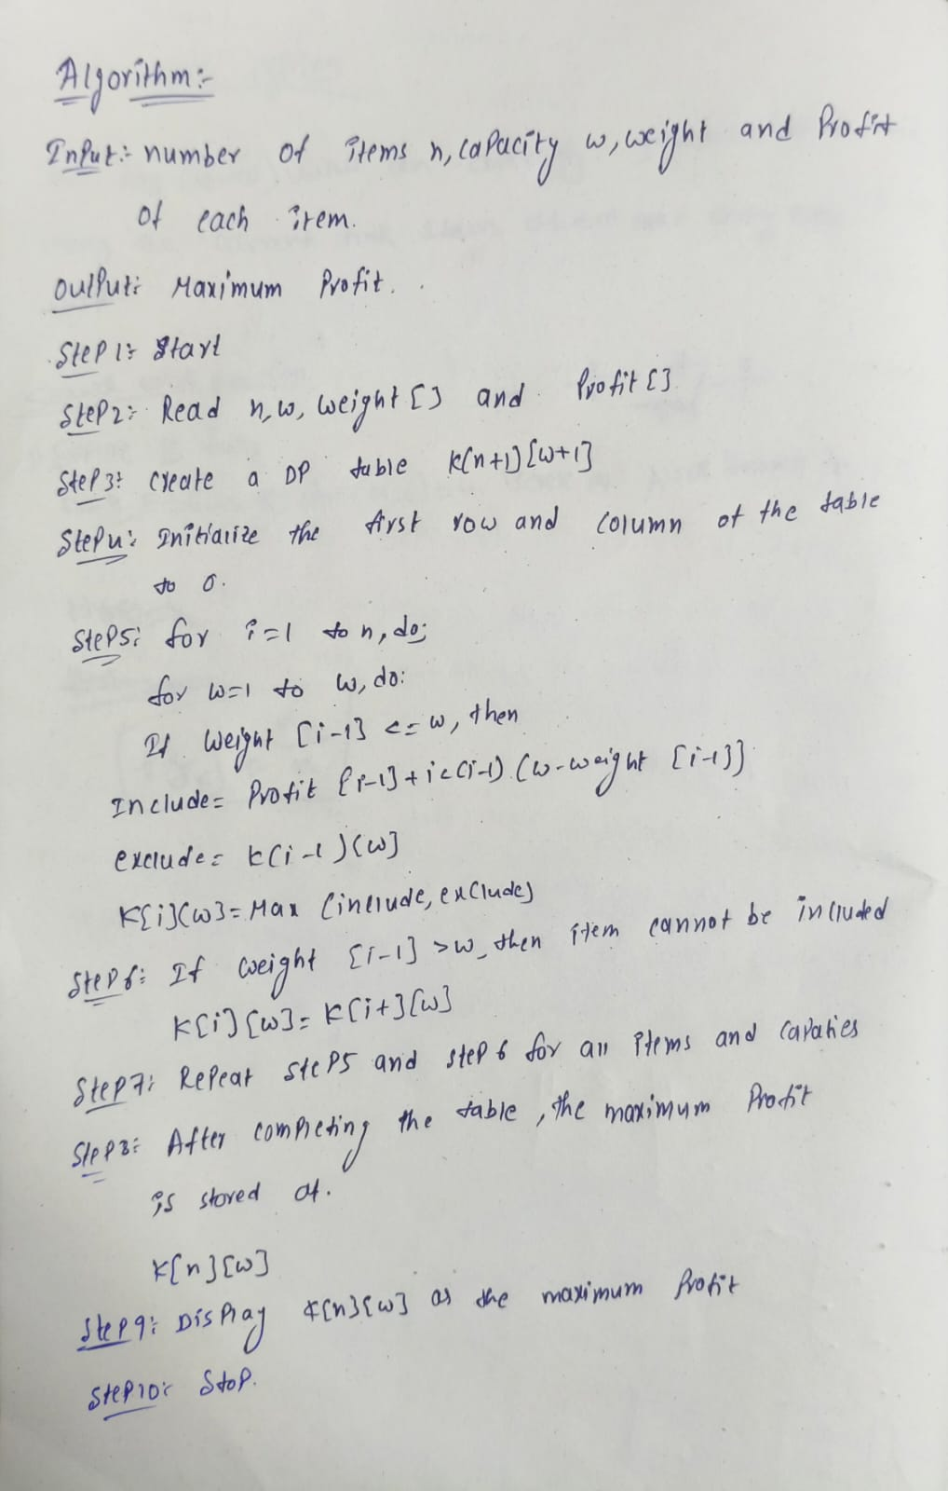

Program:

#include<iostream>
using namespace std;

class Knapsack {

private:
int w[10]; // weights
int v[10]; // values
int n; // number of items
int W; // capacity
int dp[10][100]; // dp table

public:

// ?? Get Input ??
void getInput() {
cout << "Enter number of items : ";
cin >> n;
cout << "Enter knapsack capacity : ";
cin >> W;
for(int i = 1; i <= n; i++) {
cout << "Item " << i << " weight and value : ";
cin >> w[i] >> v[i];
}
}

// ?? Build dp table ??
void solve() {

// base case - row 0 and col 0
for(int i = 0; i <= n; i++) dp[i][0] = 0;
for(int j = 0; j <= W; j++) dp[0][j] = 0;

// fill table
for(int i = 1; i <= n; i++) {
for(int j = 1; j <= W; j++) {

if(w[i] <= j) {
// take or not take
dp[i][j] = max(
v[i] + dp[i-1][j-w[i]],
dp[i-1][j]
);
} else {
// cannot take item i
dp[i][j] = dp[i-1][j];
}
}
}
}

// ?? Print dp table ??
void printTable() {
cout << "\nDP Table:" << endl;
cout << " ";
for(int j = 0; j <= W; j++)
cout << j << " ";
cout << endl;

for(int i = 0; i <= n; i++) {
cout << "i=" << i << " ";
for(int j = 0; j <= W; j++)
cout << dp[i][j] << " ";
cout << endl;
}
}

// ?? Find selected items ??
void findItems() {
cout << "\nSelected Items:" << endl;
int j = W;
for(int i = n; i >= 1; i--) {
if(dp[i][j] != dp[i-1][j]) {
cout << "Item " << i
<< " (w=" << w[i]
<< ", v=" << v[i]
<< ") TAKEN " << endl;
j = j - w[i];
} else {
cout << "Item " << i
<< " (w=" << w[i]
<< ", v=" << v[i]
<< ") NOT taken " << endl;
}
}
}

// ?? Show result ??
void showResult() {
cout << "\nMaximum Value = "
<< dp[n][W] << endl;
}
};

// ?? MAIN ??
int main() {

Knapsack k;

k.getInput();
k.solve();
k.printTable();
k.showResult();
k.findItems();

return 0;
}

Output: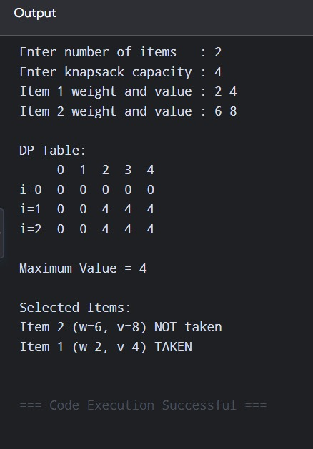

Time Complexity:

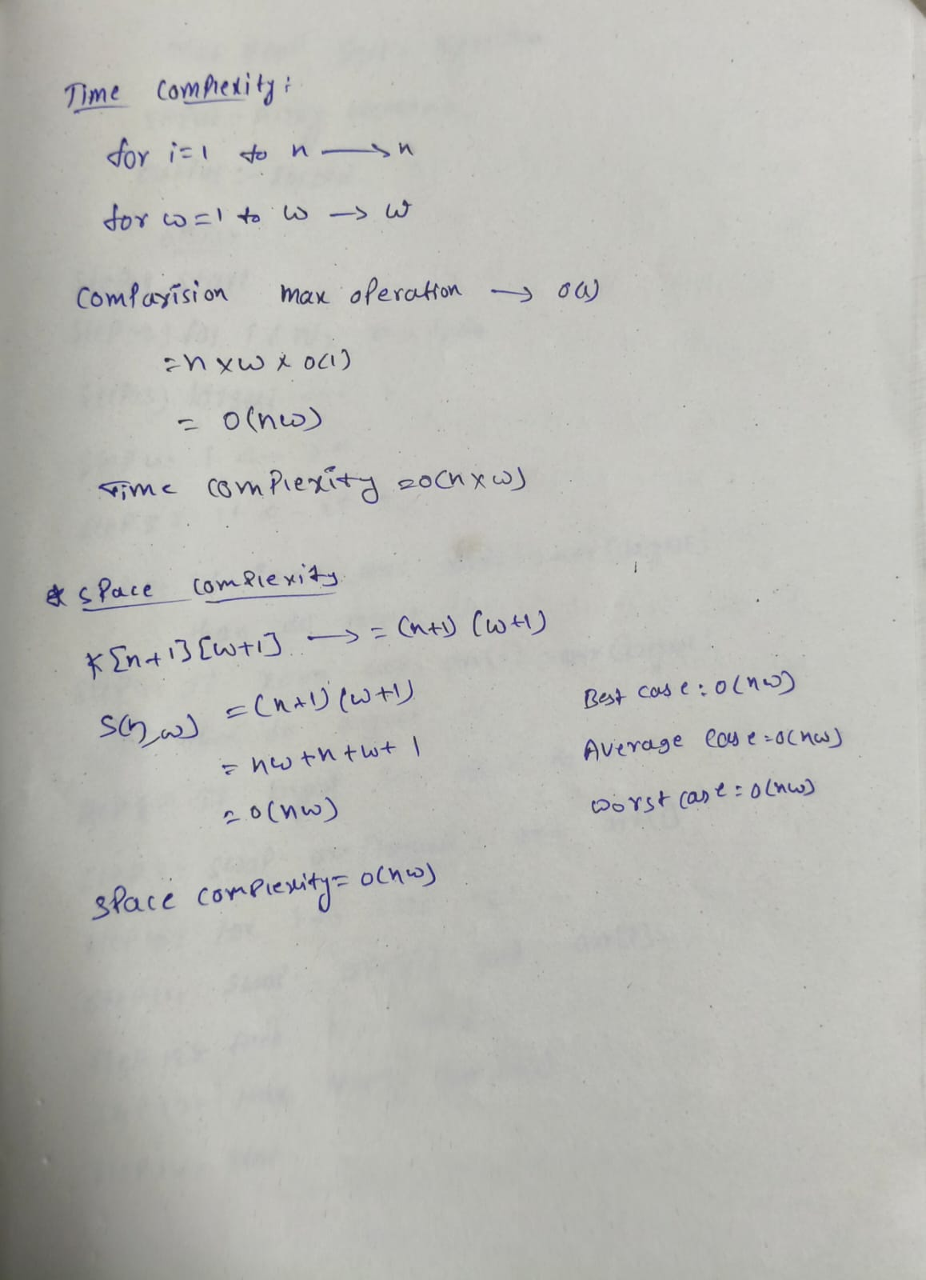

Conclusion:
The 0/1 Knapsack problem was successfully implemented using the Dynamic Programming technique. The algorithm determines the maximum profit that can be obtained by selecting items without exceeding the given knapsack capacity. The time complexity of the algorithm is O(nW), and the space complexity is O(nW). Thus, Dynamic Programming provides an efficient solution compared to checking all possible combinations.

